Question 1:
Find out the mail servers of the following domain:

Ibm.com

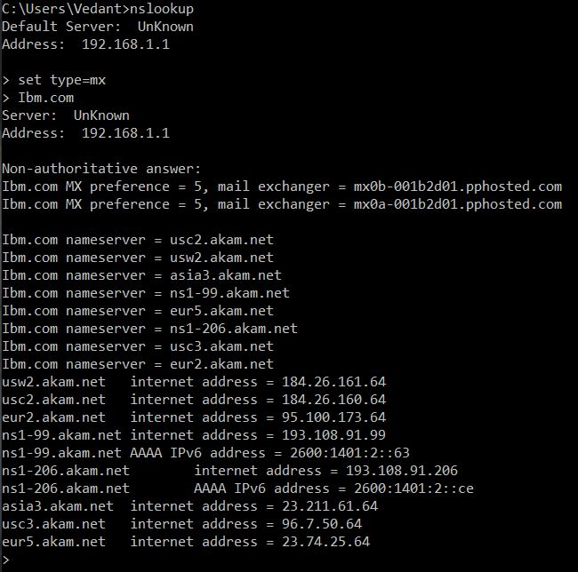
Wipro.com

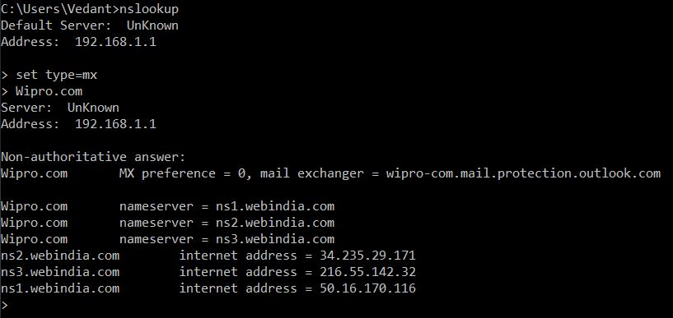

Question 2:
Find the locations where these mail servers are hosted.

Ibm.com
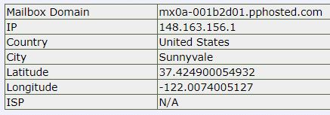

Wipro.com
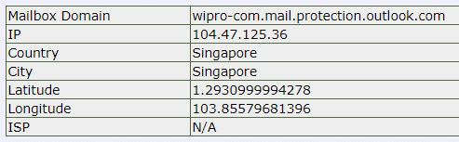

Question 3:
Scan and find out port numbers open 203.163.246.23.

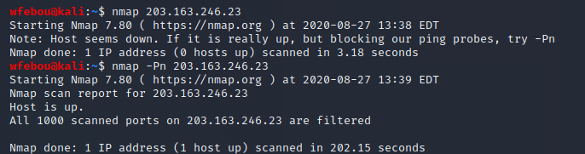
Question 4:
Install nessus in a VM and scan your laptop/desktop for CVE.
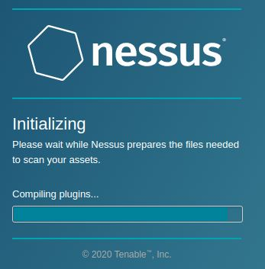

Scan results can not be uploaded for security reasons.

